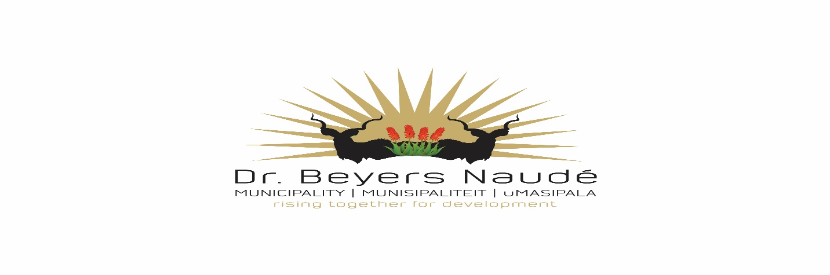

BID 29/2020
BID FOR THE PROVISION OF SERVICE PROVIDERS FOR SANITATION INFRASTRUCTURE IN INFORMAL SETTLEMENTS IN GRAAFF REINET

Bids are hereby invited on behalf of the Dr Beyers Naude Local Municipality (DBNM), for experienced service provider companies to supply, deliver, install and commission various items required in order to equip the Nqweba Dam Pumps as per the required specifications.

A non-compulsory site meeting will take place at the Robert Sobukwe Building in Graaff Reinet at 12 P.M, Friday 12 June 2020
Bidding documents can be requested from Mr Jaco Morgan at Jaco@la-eng.co.za/0832286113
Bids must be placed in the municipal tender box, Robert Sobukwe Building, in sealed envelopes clearly marked "BID 29/2020", not later than 12h00 on Wednesday, 17th of June 2020 and will be opened in public immediately thereafter.
Note:
- Faxed, e-mailed or late quotations will not be accepted.
- Price to include VAT (if registered for vat) and disbursement costs involved with the project.
- The tender will be evaluated on 80/20 system.
- All suppliers must be registered on the CENTRAL SUPPLIER DATABASE. Log onto www.csd.gov.za for registration.
- Most recent CSD registration reports must be submitted.
- Attached declaration of interest form needs to be completed.
- SARS Verification pins to be supplied.
- No upfront payments
- General conditions (National Treasury) will apply
- Bidders should deem themselves unsuccessful if not contacted within two weeks after closing
- A current certified Municipal (rates & services) clearance certificate to be submitted.
- A current certified BBBEE status level certificate must be submitted in order to claim preference points.
- Council is not bound to accept the lowest or any tender and reserves the right to accept any tender or part thereof.
- For further details contact, Mr J. Morgan at 0832286113

DR. E.M. RANKWANA
MUNICIPAL MANAGER

